**ADR Projects on Git repository & Guidelines to manage**

We are using the Git repository for maintaining the project versions for various projects in ADR.

In this document I have briefed in detail about using the Github for Fotopia & Fokatech Project.

We have to use the below credentials to login in to github to access and manage our repositories.

https://github.com/login

info@adrgrp.com / Bitech7410

Login using the above credentials and you can see the list of repositories in left side that are managed through the current login. Click on Show more will show all the repositories.

To create a new repository for a new project, follow the below guidelines and steps:

Click New button shown in below screenshot

I have created a repository for Fokatech website to show the steps to create and manage the Git hub for new projects version controls

Repository name is Fokatech-Site (You may provide the name as per the project). And the repository is created as Private.

Once created, you will be redirected to the below screen.

To Start with the repository, click on any of the below option available in above screenshot.

Creating a new file – you can click this link and the editor screen will open and type some text and create and save a file.

Uploading an existing file – you can click on this option to upload a at least one file from your project.

When at least one is created or uploaded, then the repository will be available with Trunk and branches automatically. Once the file is created / uploaded, click on Commit changes

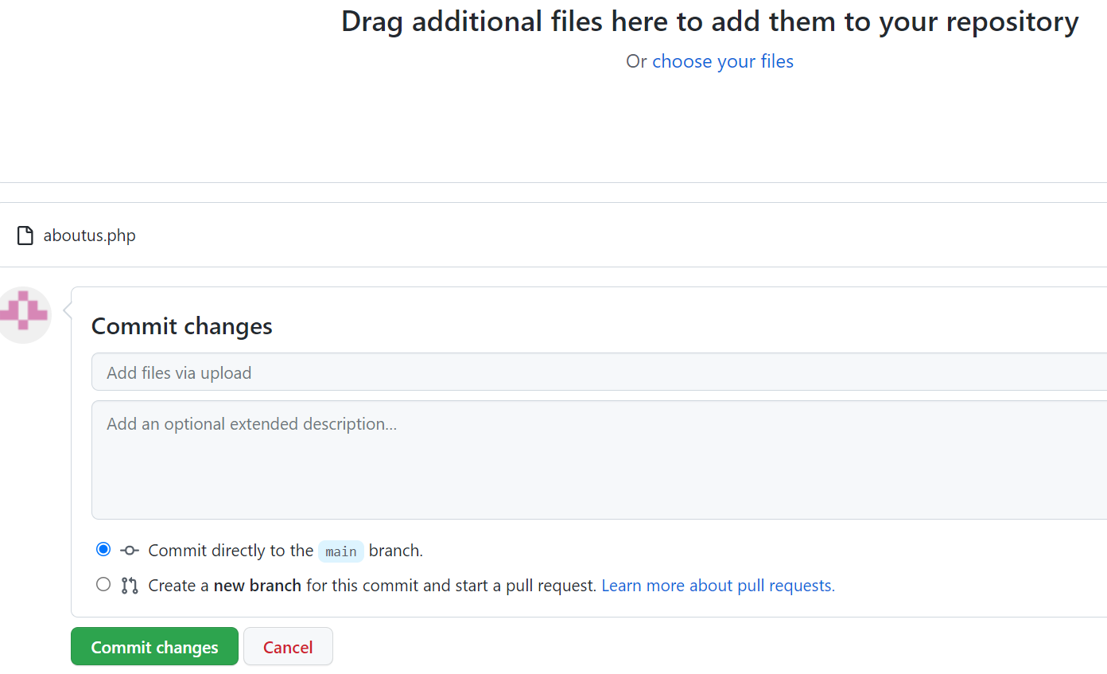

From the above screenshot the Git hub url from this fokatech-Site is <https://github.com/adrgrp-dev/Fokatech-Site.git>.

When you try to check out using Tortoise SVN you will get “Trunk” and “branch” folders. Inside Trunk you can find the file that you have just uploaded.

For quick access use the url end with trunk while checkout. i.e like below

[https://github.com/adrgrp-dev/Fokatech-Site.git/**trunk**](https://github.com/adrgrp-dev/Fokatech-Site.git/trunk)

1. Go to any drive in your pc (ie E drive)
2. Create a folder for your Fokatech-Site

1. Right Click and click on “SVN Checkout”. (Make sure you have installed Tortoise SVN already). Otherwise install Tortoise SVN in your pc and try again right click and go ahead.
2. The below screenshot popup will be shown, and you can paste the SVN URL in the URL of repository like below.

<https://github.com/adrgrp-dev/Fokatech-Site.git/trunk>

Click on Ok to check out the files from the Fokatech-Site repository.

You may face this error while checkout

Which means the current user is not authorized to this repository or the repository is not available for public.

Now go to Git hub login using [info@adrgrp.com](mailto:info@adrgrp.com), and do the below steps.

Click on Fokatech-Site repository from left side menu after login

Click on Settings tab



Click on Collaborators from left side.

Then click Add People from above screen

Search the team mate and select from the suggestion

Once user selected, Click on add button

An Invitation will be sent to the selected user in email (see below screenshot). Once they follow the link from email and accepted the invitation, then they can be able to access to the given repository.

Click on accept.

It will show the below screen and click on accept invitation.

Now again Try to check out from SVN

In the above screen shot You can see the file that you have uploaded at first time.

Now, Copy and paste all the Fokatech-Site full project here in E:\Fokatech-Site folder

Here you cans see only aboutus file seems with green tick. Which means that file only available in repository. So now we have to push all other files in to git by using 2 steps.

1. Right click - > Tortoise Svn -> +Add

Popup window will show like this

Click on Ok

Then the below screenshot popup will shown as the files are added with status Completed.

No of files added i.e 174

Click on Ok.

Now again right click and Select “SVN Commit”. Below screenshot will be shown. Put some comment and click on Ok

It will commit all files into repository and show completed. Then click on Ok button

Now you can see all the files in E:\Fokatech-Site will be with green colour tick. Which means the local and Git repository files are same version.

So from Next time and everytime take Updated before commit your code changes.

To Update – Right click – then select “SVN Update”

To Commit – Right click – then select “SVN Commit”

------------------end of document -------------